**ALM Notes**

**Sites**

<http://alm3/qcbin>

**Reference**

System Testing/Enterprise Release 14.3/PP Avanteos Term Deposits

.

JCL: SDAF.PPAVENT.CNTL.TEST.DESIGNER(CF180D9A)

Input file: SDAF.CF.CF180.DD761.GODXDATA

Output file: SDAF.CF.CF180D9A.ACCTS.PRIMARY.CUST

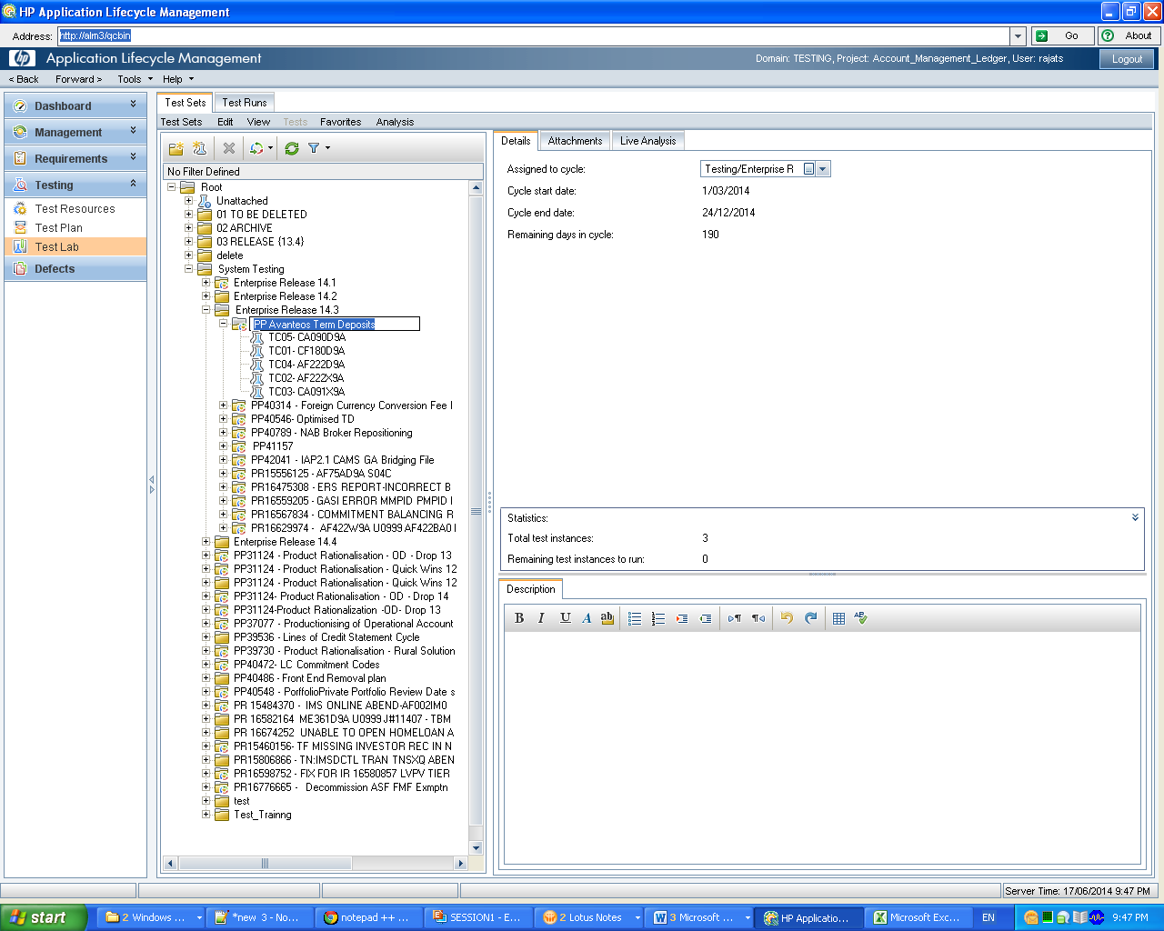**Logging into ALM**

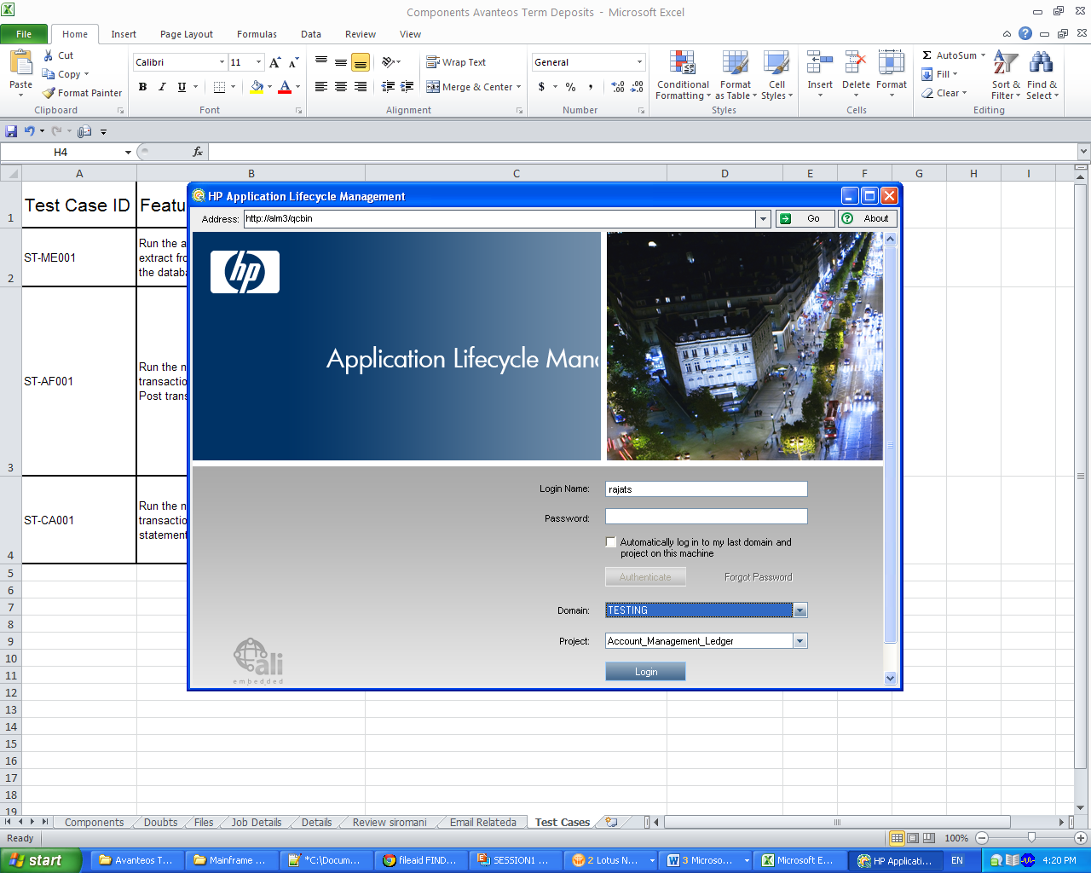

**Creation of Test Cases in ALM**

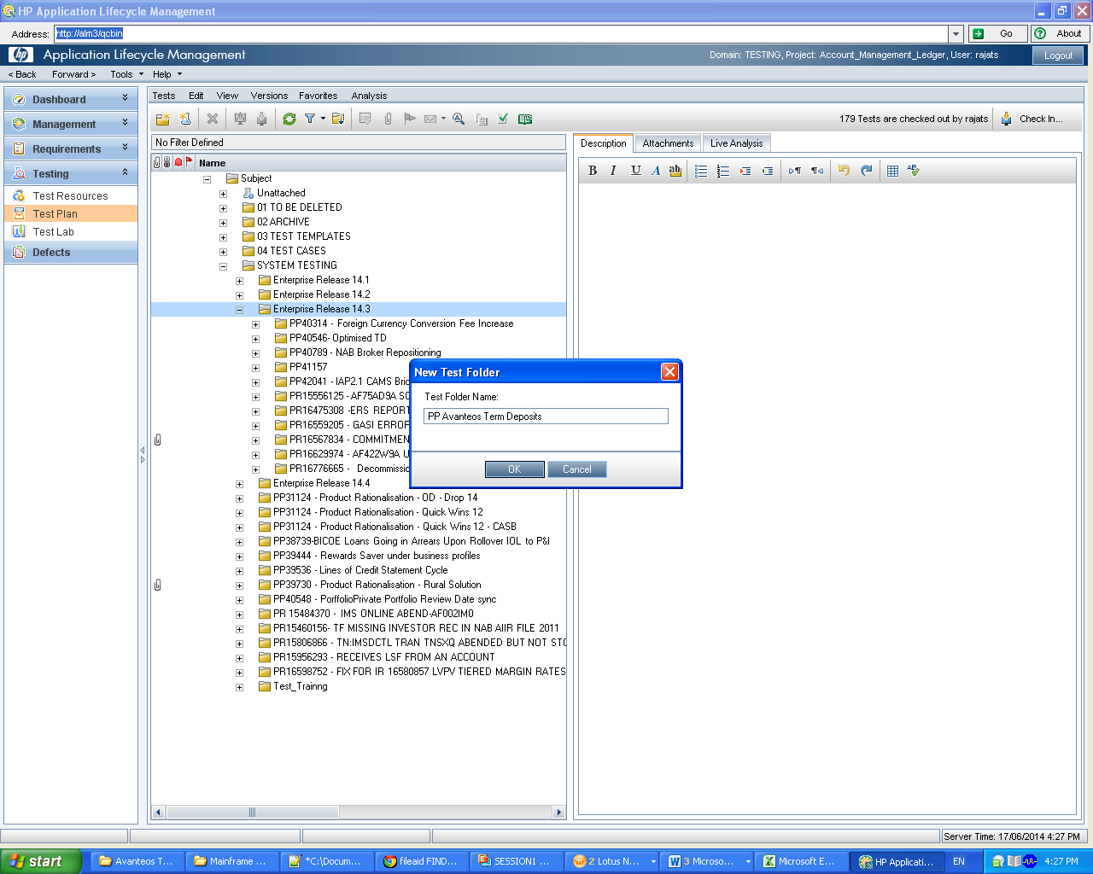

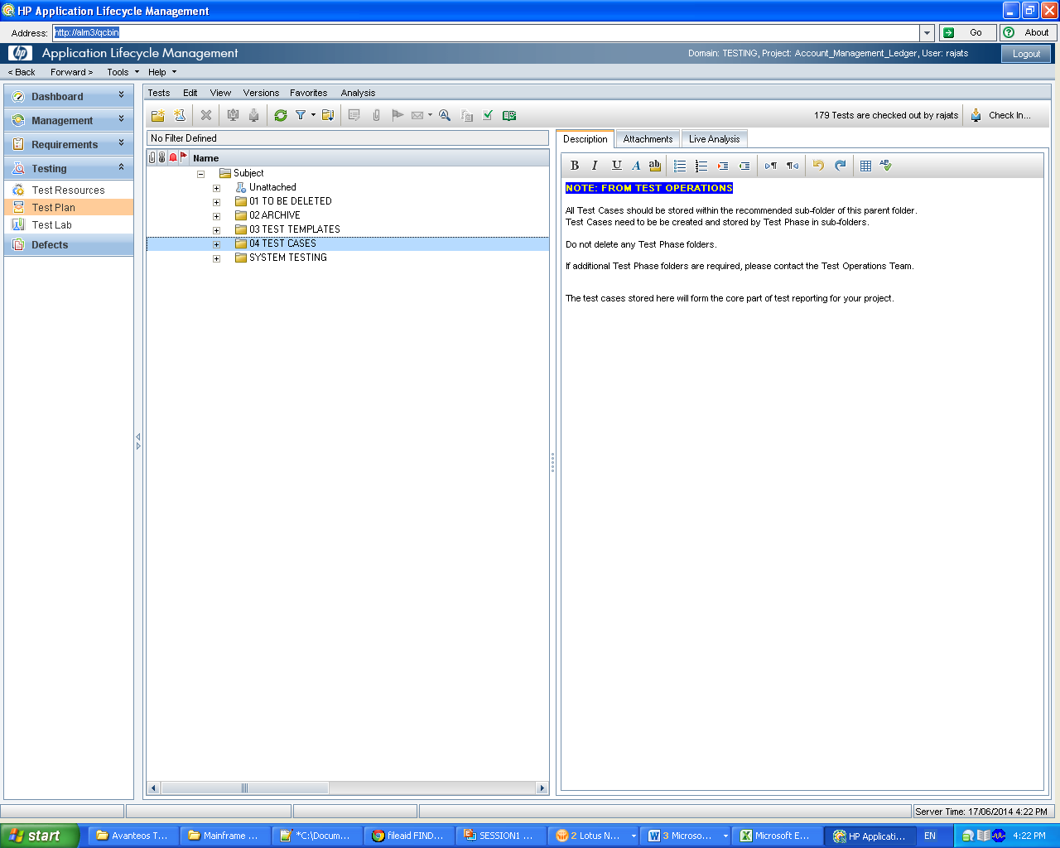

**Project**: Bank Enterprise Release 14.3_48465 (Please note that this is 14.3 release)

System Impact: CAMS - Product Rules_BA1095

Test Stream : Testing Services

Type of Test : Functional

Batch Group : online

After entering above details press Ok.

**Description :**

**Account creation**

**Test Case Description:**  
Open LFDA fixed account and Perform Transaction through EBOBS.  
  
**Test Case Expected Result:**  
Account open and Value transaction should be successful.  
  
**Pre-Requisites:**  
Customer should exist  
  
**Logon:**  
  
**Dependencies:**  
Test Case Dependencies  
  
**Batch Dependencies**

**Batch**

**Test Case Description:**  
Run batch for processing date: 11/07/2014  
  
**Test Case Expected Result:**  
Batch should run successfully

**Pre-Requisites:**  
Processing day & Next day buffer should exist  
  
**Logon:**  
  
  
**Dependencies:**  
Test Case Dependencies  
  
  
Batch Dependencies

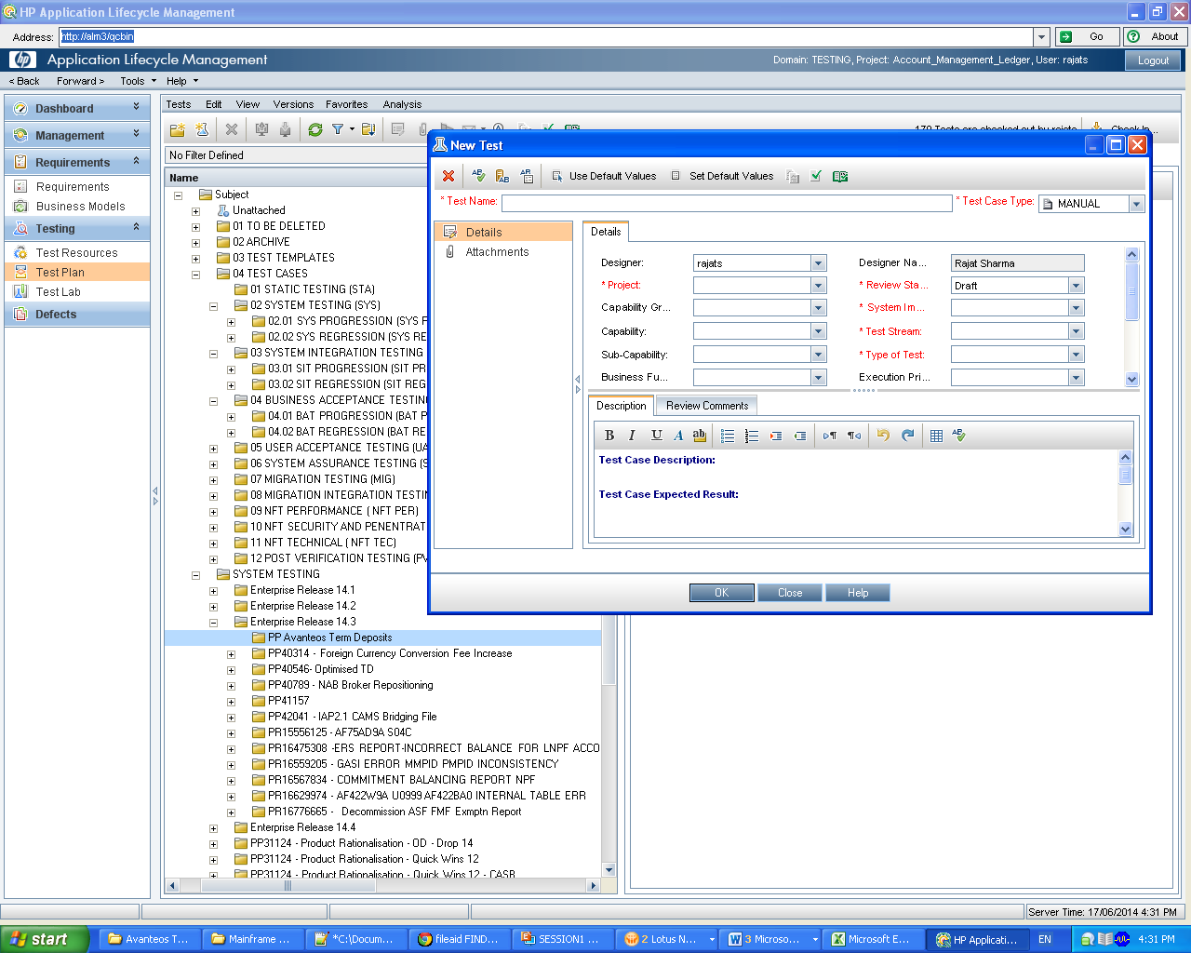

**STEP Creation**

Description :

Run batch for processing date: 11/07/2014

Expected Result

Batch should run successfully

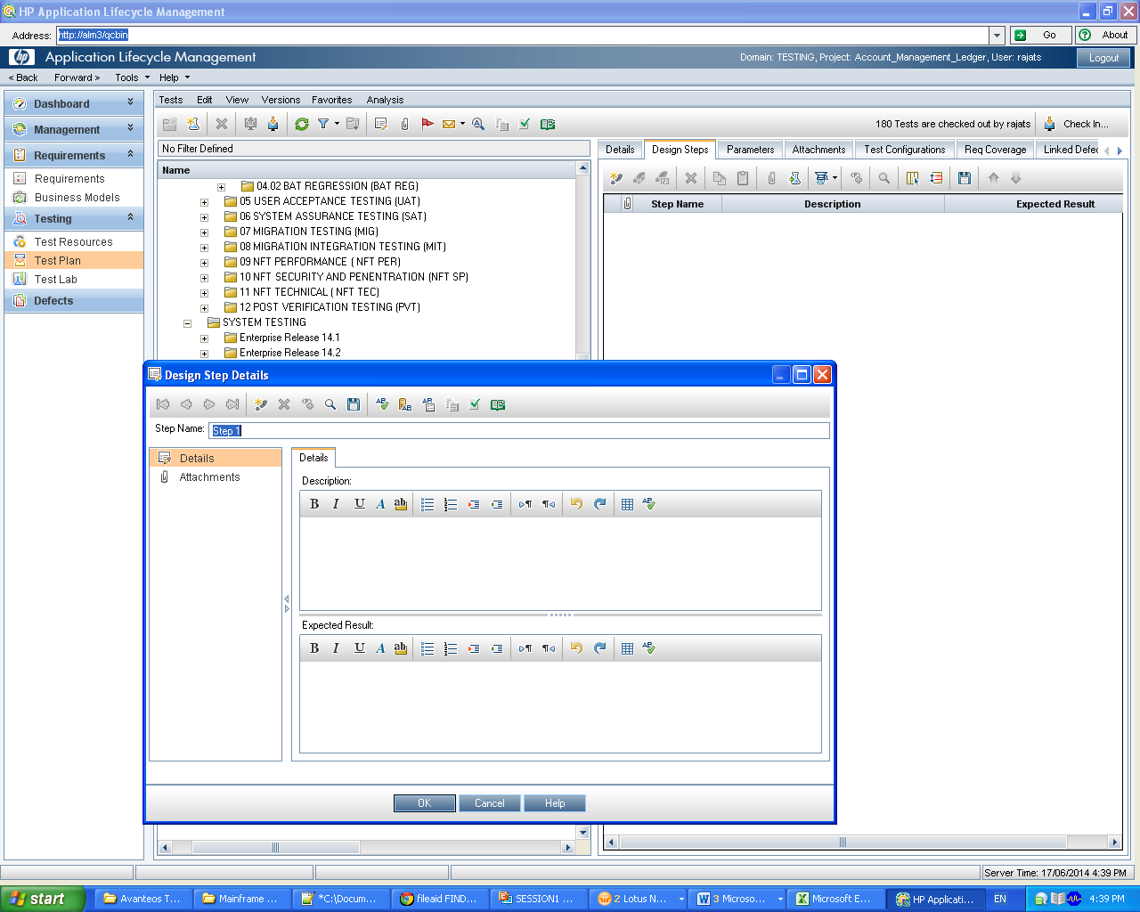

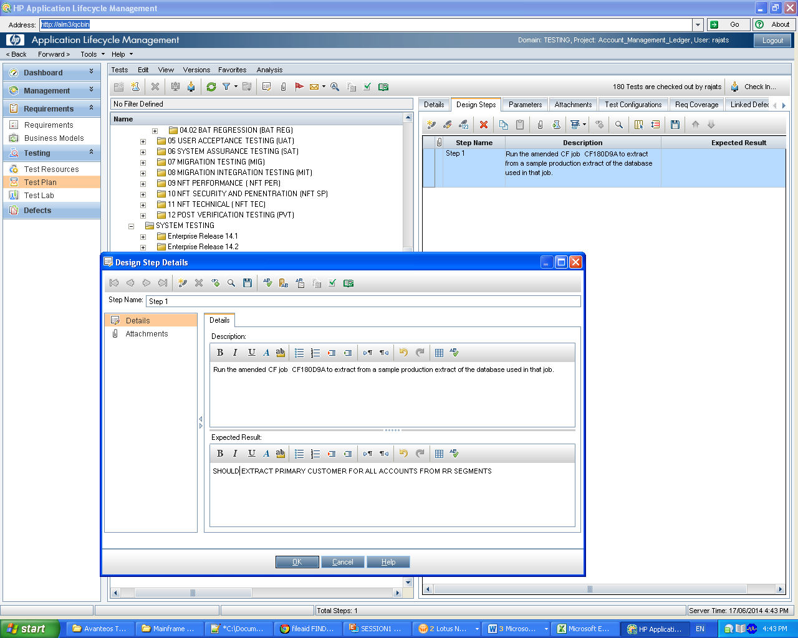

**Go to TEST LAB**

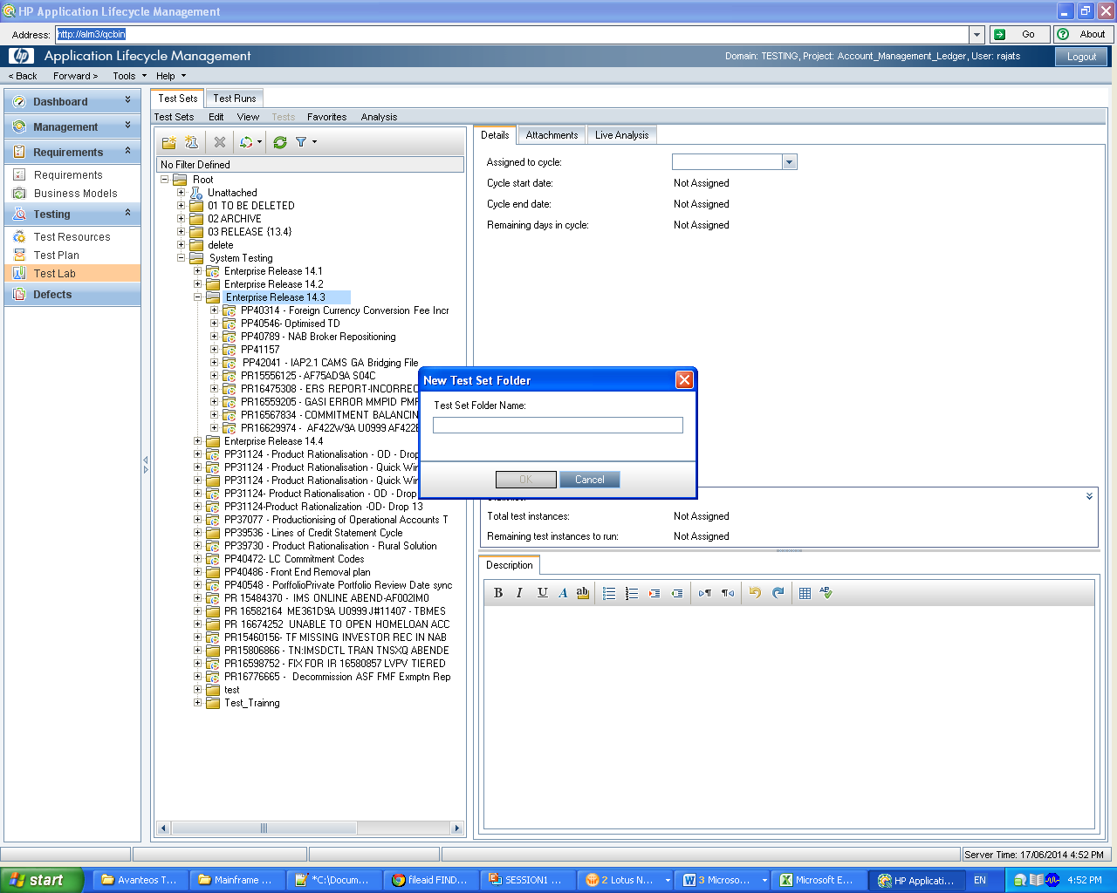

**Test Phase :** Test - System Testing

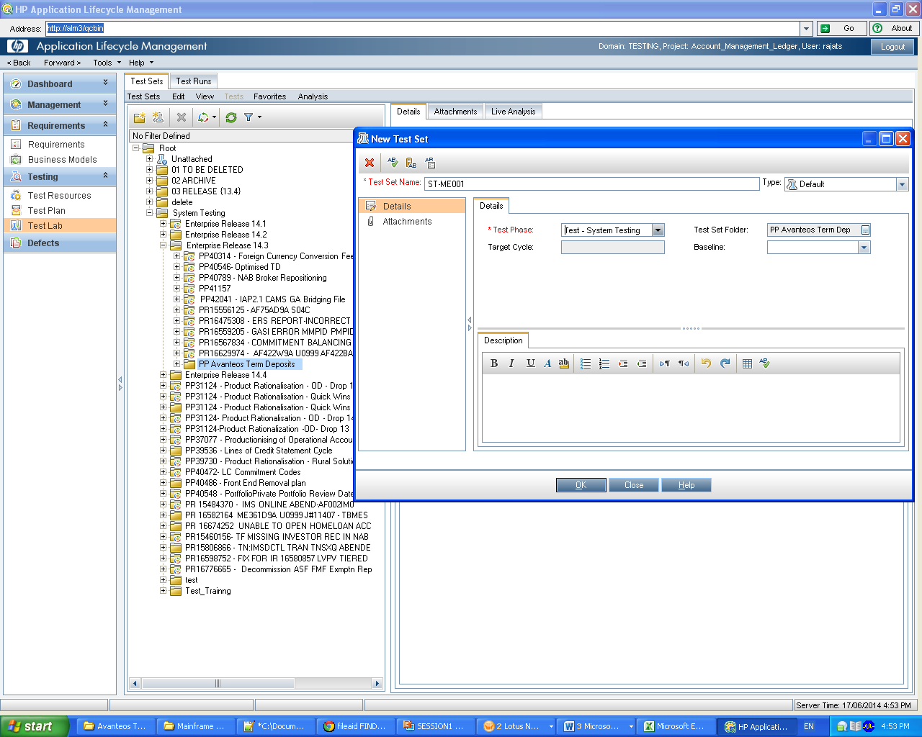

Mapping Test lab testcases with test plan test cases

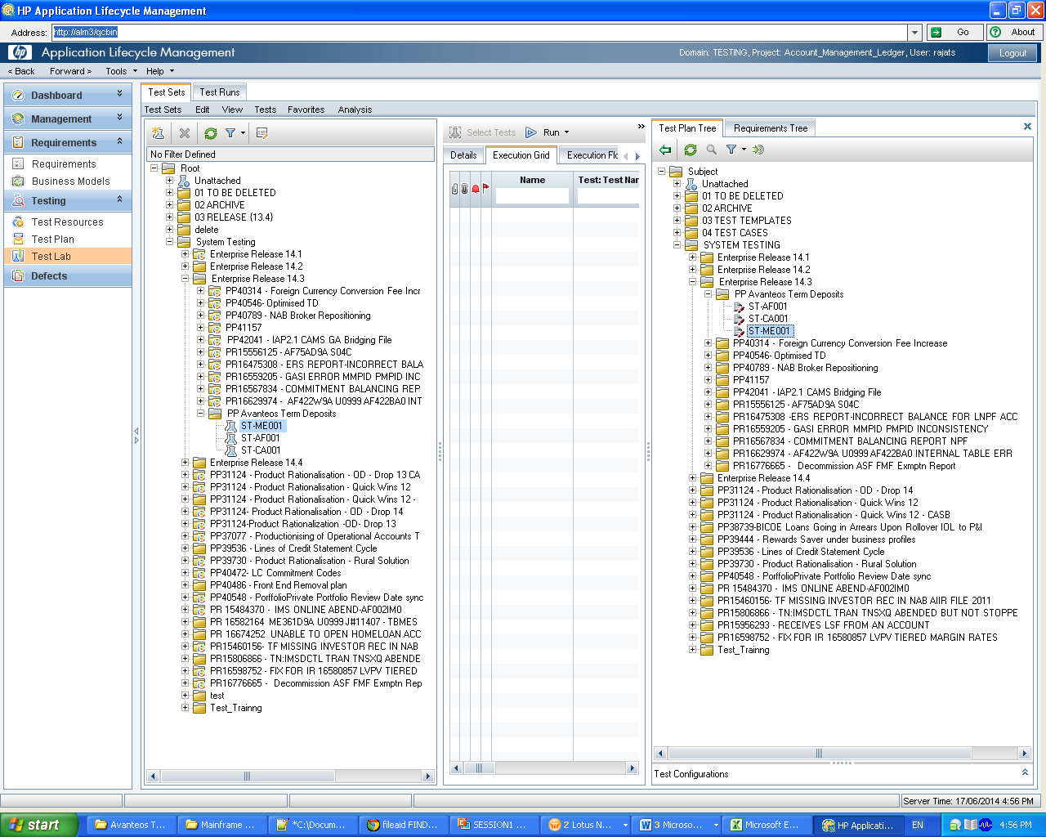

Assign to cycle

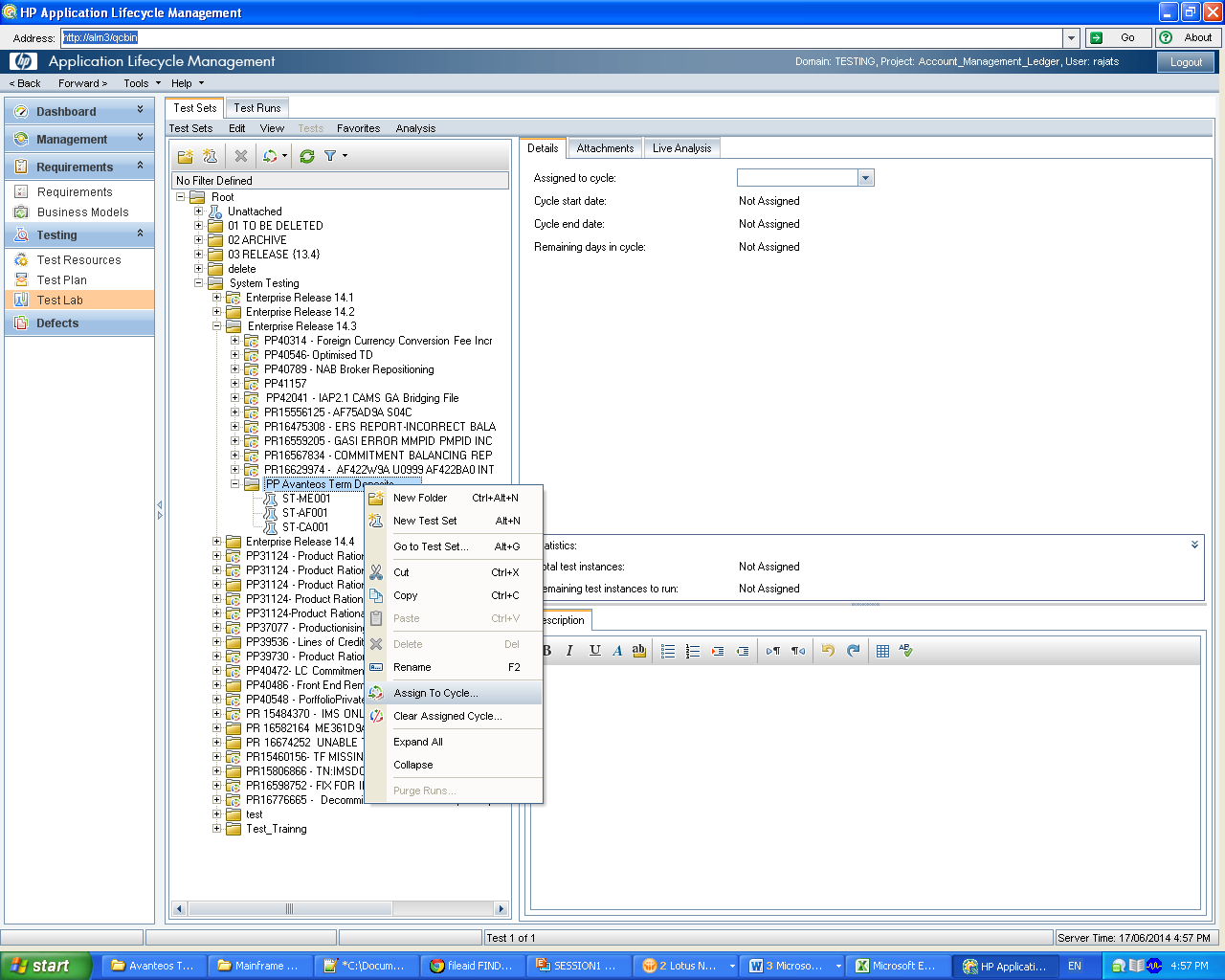

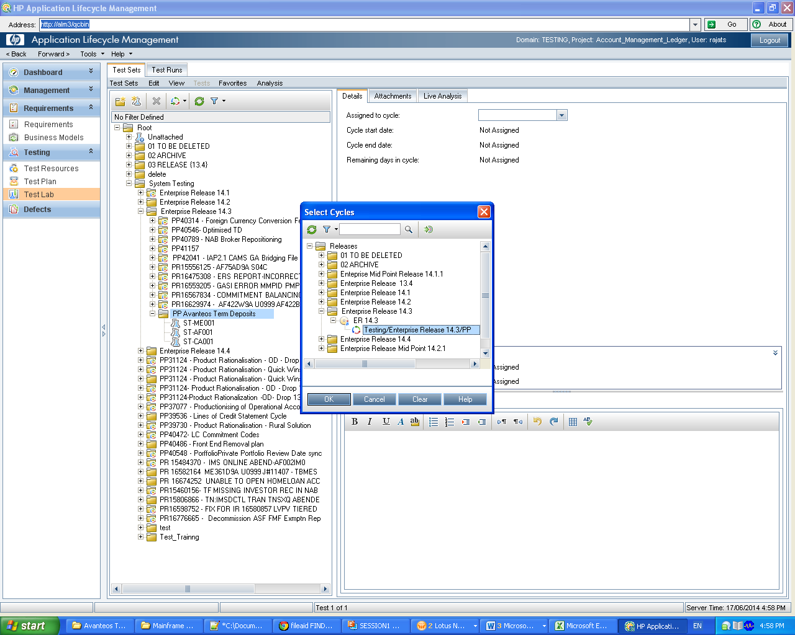

Give Planned execution date as todays date

